Group Rental Information Sheet


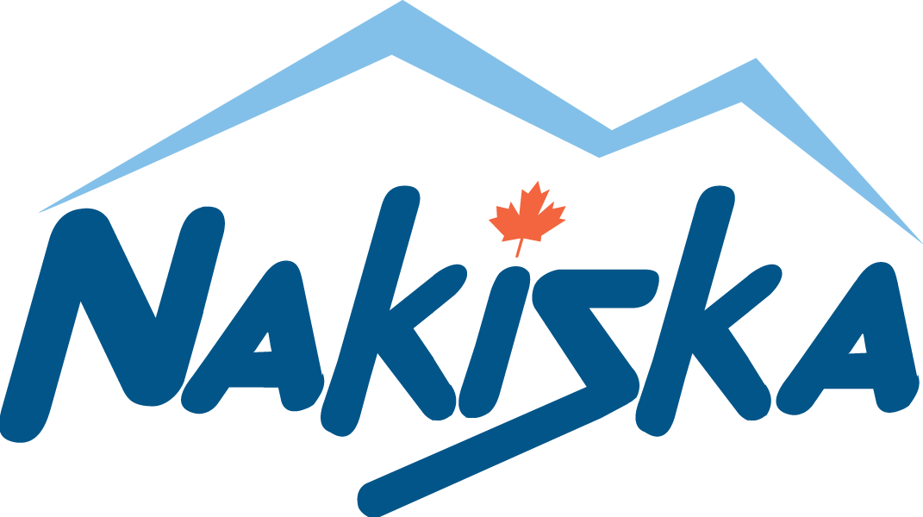
Page _____ of _____
Resort: Please Check One: 
Group Name: ________________________ Coordinator’s Name: ____________________ Current Date: ____________

Phone: _____________________________ Trip Dates: ___________________________

 | Required for ALL Participants |  |  |  |  |  |  |  |  |  | Lesson and Rental Participants
 |  |  |  |  |  | Check all that are required |  |  |  |  | Skiers and Snowboarders |  |  |  | Snowboarders Only
# | Name |  |  | Age |  | Lift Ticket | Lesson | Ski Rental | Snowboard Rental | Helmet Rental | Ability Level  (See chart Below) | Height | Weight | Shoe Size | Regular or Goofy (R or G)  G-Right Foot Forward  R-Left Foot Forward
1
2
3
4
5
6
7
8
9
10
11
12
13
14
15
Totals |  |  |  |  | Totals

Level 1:
Zero or little experience
Unable to ride lifts alone

Level 2:
Experience on gentle green slopes, Experience with surface lifts
Skiing- Able to perform braking, snowplow and basic turns
Snowboarding- Some experience with chair, Able to side slip on at least one edge, Balance is shaky, concerned about speed and falling, Hesitant on linking turns
Level 3:

Skiing- Experience on steeper green slopes, Able to straight run with skis parallel, Able to link wedge turns with confidence
Snowboarding- Comfortable on any lift, Able to side slip on toe and heel edge, Links turns with ease and engages some edging, Most green slopes are considered “too easy”, Beginning to ride switch, Less concerned with falling
Level 4:

Skiing - Experience on gentler blue slopes, Able to link turns with skis in parallel position

Snowboarding - Linking turns with edge control, Comfortable on most blue runs, Strong Balance, Not concerned with falling, Comfortable riding switch, Eager to try varied snow conditions and terrain
Level 5:
Skiing and Snowboarding
Experience with all types of lifts, Experience on steeper blue and moderate black slopes, Can link turns with edge control, Able to carve at will, Excellent speed control, Enjoy varied snow and terrain conditions

